USA Crits individual standings after 10/12 races.
5. Euris Vidal
7. Rafael Meran
12. Alex Bremer
14. Dan Chabanov
15. Alejandro Guzman
49. David Forkner
99. Adam Alexander
MANGOSEED RESTAURANT - W.S. UNITED'S GRAVEYARD SERIES @ FLOYD BENNETT FIELD
9/9/2012
CAT 1,2,3
1. Euris Vidal
3. Adam Alexander
4. Rafael Meran
5. Alejandro Guzman
Hunter Mountain Fall Classic
9/8/2012
Cat4
13. Mark Petimezas
Green Mountain Stage Race
Pro 1:
28. Dan Chabanov
United States National Master ITT Championship:
9/5/2012
55 plus
27. Tom Kempner
50 plus
30. Ric Wolf

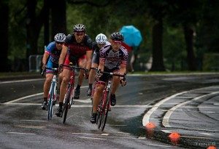
Rob Weitzner wins the CRCA Master's Throwdown
In the Men’s 50+ a four man breakaway ruled the day with Rob Weitzner (CRCA/Foundation) outsprinting Thomas Luzio (Deno’s Wonder Wheel), Pascal Sauvayre (CRCA/BH-Comedy Central) and David Carr (CRCA\Setanta). The 60+ winner was Bill Anderson (CRCA / FGX Racing).
Tour De Fair Haven
Pro 1-2
3. Rafael Meran
13. Alejandro Guzman
39. Adam Alexander
41. Euris Vidal
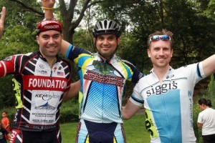
Efrain Molina - Cat4 2nd Place
CRCA Mengoni Grand Prix
Presented by Century Road Club Association and GS Mengoni USA
Central Park, NY
Saturday, August 11, 2012
Pro 1-2-3
9. Rafael Merin
11. Euris Vidal
21. Gavin Robertson
29. Alejandro Guzman
35. Antonio Munoz
41. Abraham Soler
CAT3
3. John Blake
13. Steve Hylton
19. Ron Ferraz
37. Jamaul Nichols
43. Jimmy Andrello
CAT4
2. Efrain Molina
13. Mark Petimezas
59. Mauricio Sanchez
64. Rob Weitzner

